Agrovision

26-29 November 2021

Reshimbagh Ground, Nagpur

Standard Operating Procedure/ Preventive measures

Measures to be followed byExhibitors

- 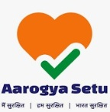AarogyaSetu Mobile App is recommended for all the persons manning the stall and is mandatory for the ones with asmart-phone.

- All the stalls should have hand sanitizers. They should ensure that a sufficient gap (of two yards) is maintained at all time between the people manning the stall. All the personnel at the stall should use Face Mask, till COVID-19 remains a healthhazard.

- Every stall should have a covereddustbin.

- To maintain social distancing the number of individuals that can be permitted in any given stall / booth at any particular time may be moderated such that the latest MHA / MoHFW guidelines on social distancing are complied-with.

- Exhibitors should encourage Digital Payment Options at Food & Beverage (F&B)outlets.

Measures to be followed by Business Visitors /Delegates

- 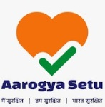AarogyaSetu Mobile App is recommended for all the visitors and mandatory for the ones with asmart-phone.

- The visitors should not enter the venue ground if their temperature is notnormal.

- They should wear face mask at all the time.

- The visitors must ensure that they maintain a sufficient distance (of about two yards) from other persons at all thetime.

- In case a person falls sick, he must report to the First Aiddesk.

- They should pre-register themselves.

- They should adhere to all the guidelines prescribed by the Trade Fair organizer.

